STRUCTURED QUERY LANGUAGE

SQL

▪ SQL stands for Structured Query Language and it is a standard and domain specific computer language used for managing data in relational database management system which stores data in the form of tables and also to retrieve and update data in a database.
▪ SQL works with database like DB2, MySQL, PostgreSQL, Oracle, SQLite, SQL Server, Sybase, MS Access

MySQL

▪ MySQL is an Oracle-backed open source relational database management system
(RDBMS) based on Structured Query Language (SQL).

Installation

▪ Prerequisite for Windows
✓ Microsoft .NET Framework 4.5.2
✓ Microsoft Visual C++ Redistributable for Visual Studio 2019
✓ Microsoft Windows 10 or Windows Server 2019
▪ Downloading MySQL 8.0.25
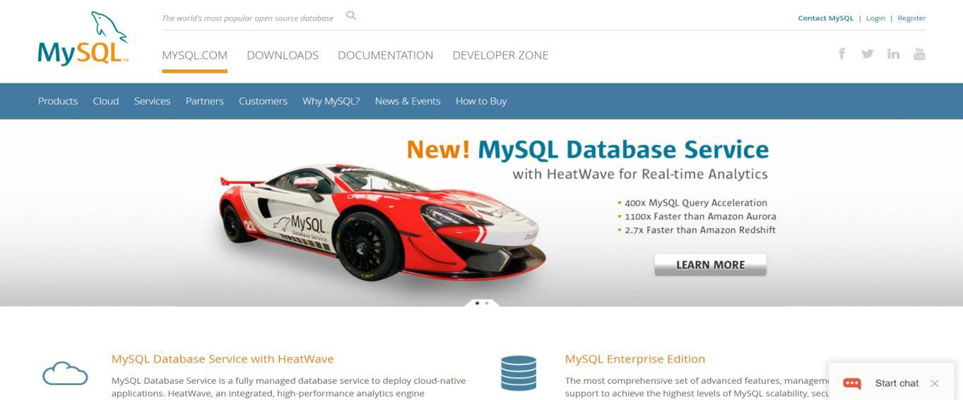✓ Step-1: Go to the official website https://www.mysql.com/ and click on the downloads as shown in the figure

✓ Step-2: Click on the MySQL Community(GPL) Downloads and the click MySQL Installer for windows as follows
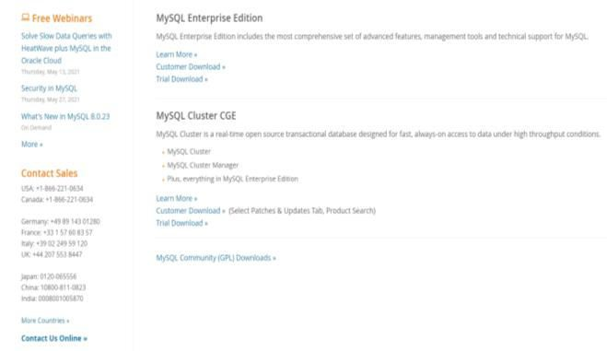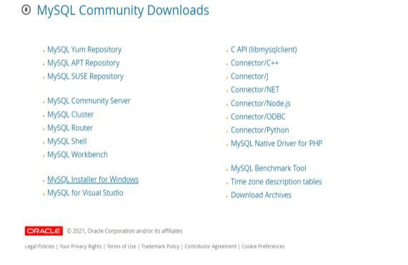

1 2

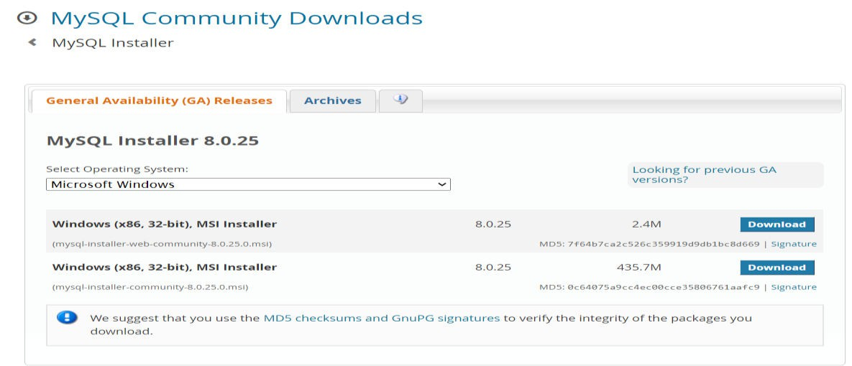✓ Step-3: Click on Window(x86, 32-bit), MSI Installer with 435.7M

▪ Installing MySQL
✓ Step-1: Double click the MSI installer .exe file. It will give the following screen. (The exe file can be found in Downloads folder in the PC)

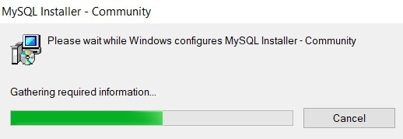

✓ Step-2: In the next wizard, choosing the Setup Type, There are several types available, and you need to choose the appropriate option to install MySQL product and features. Here, we are going to select the Custom option and click on the Next button.
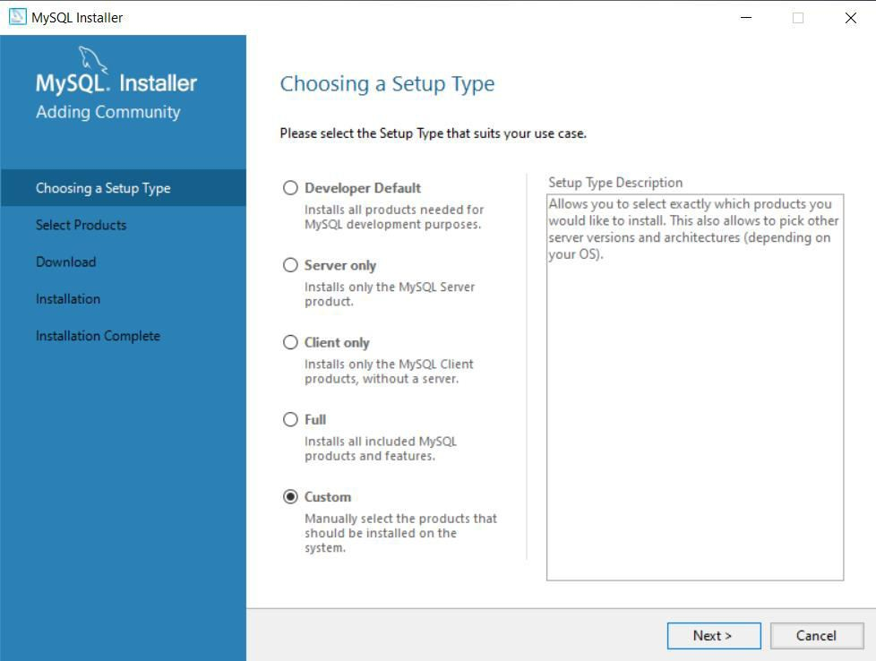

1

2

✓ Step-3: In Select Product we need MySQL Server, MySQL Workbench, MySQL Shell. So, we select MySQL Server 8.0.25-x64, MySQL Workbench 8.0.25-x64, MySQL Shell 8.0.25-x64 from available products and drag them to products to
be installed panel and click next

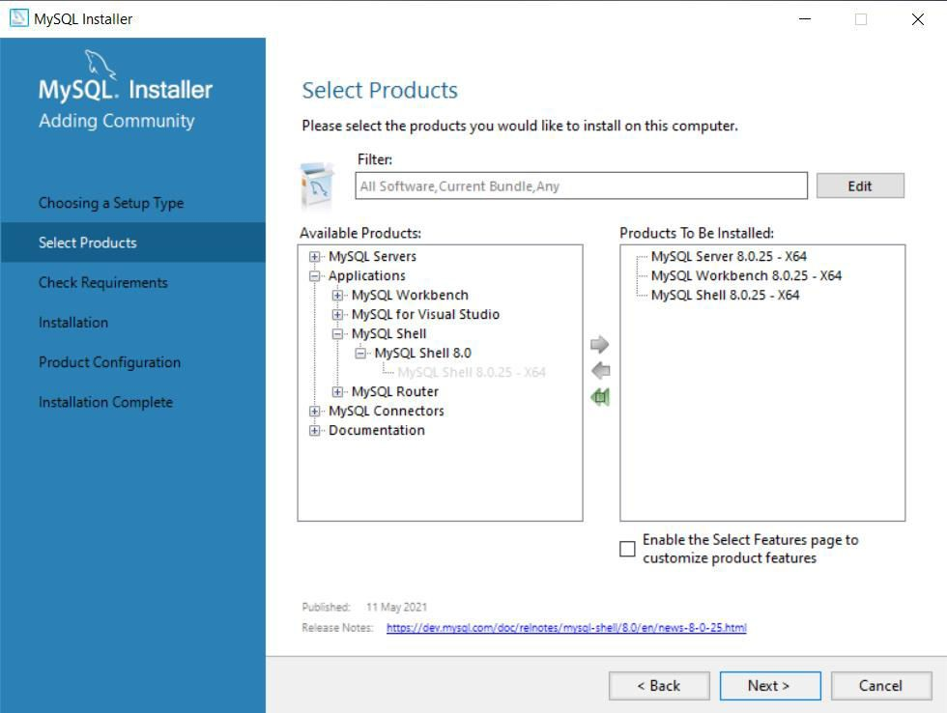1

2

✓ Step-4: In Check Requirements, wizard checks the all the prerequisite are available, if not it prompts to install the required software after the agreement
and installation click next as shown in the figure

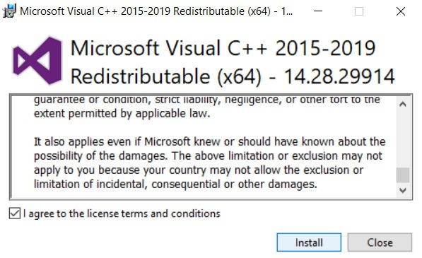1
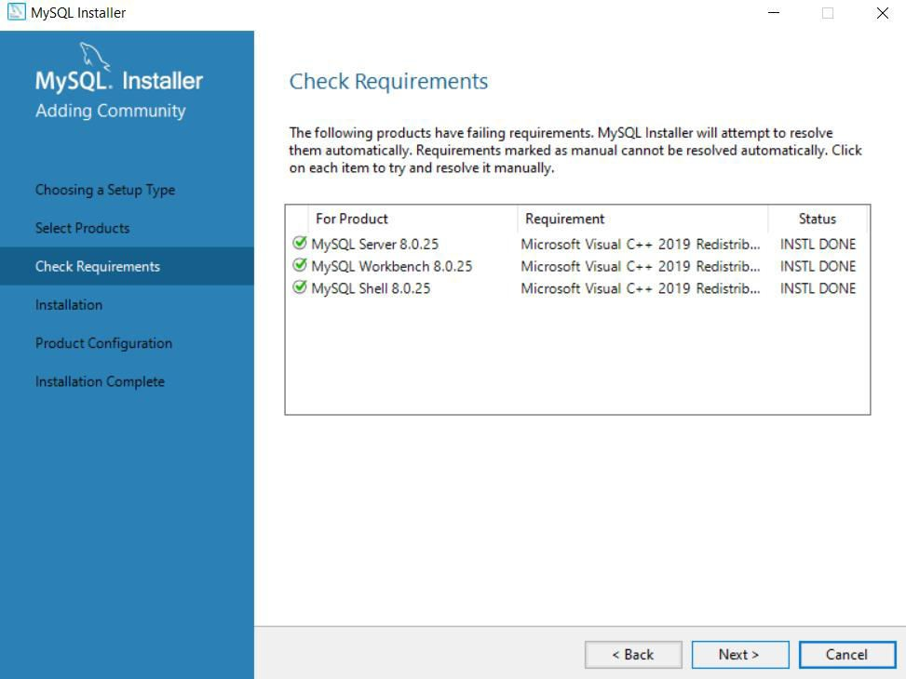

2

✓ Step-5: In Installation Click Execute to install the selected packages after the status is changed to complete click Next as shown

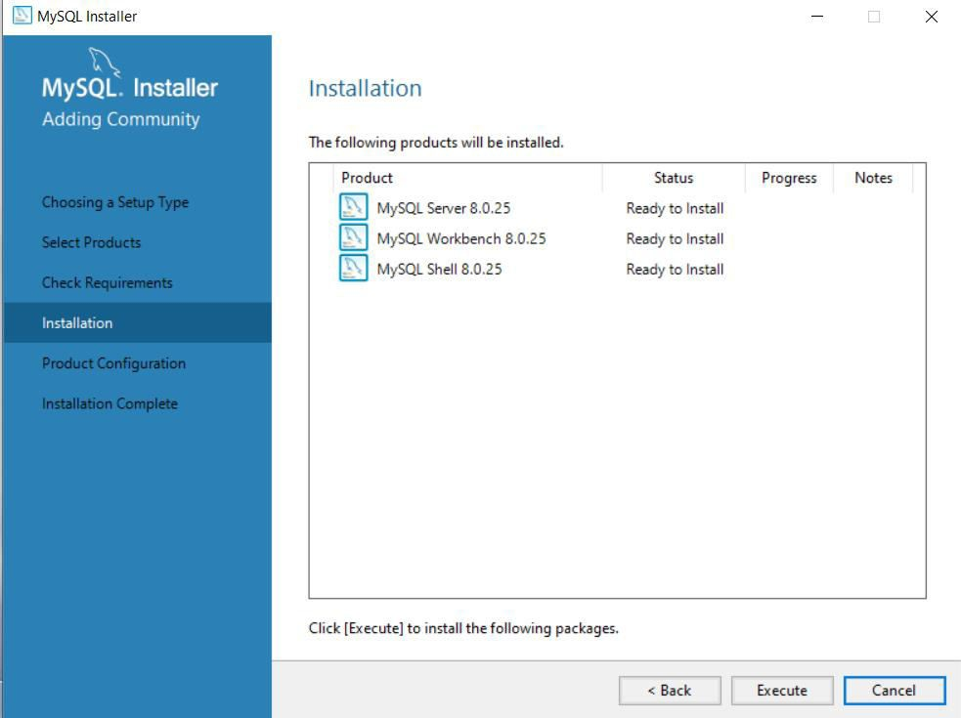1

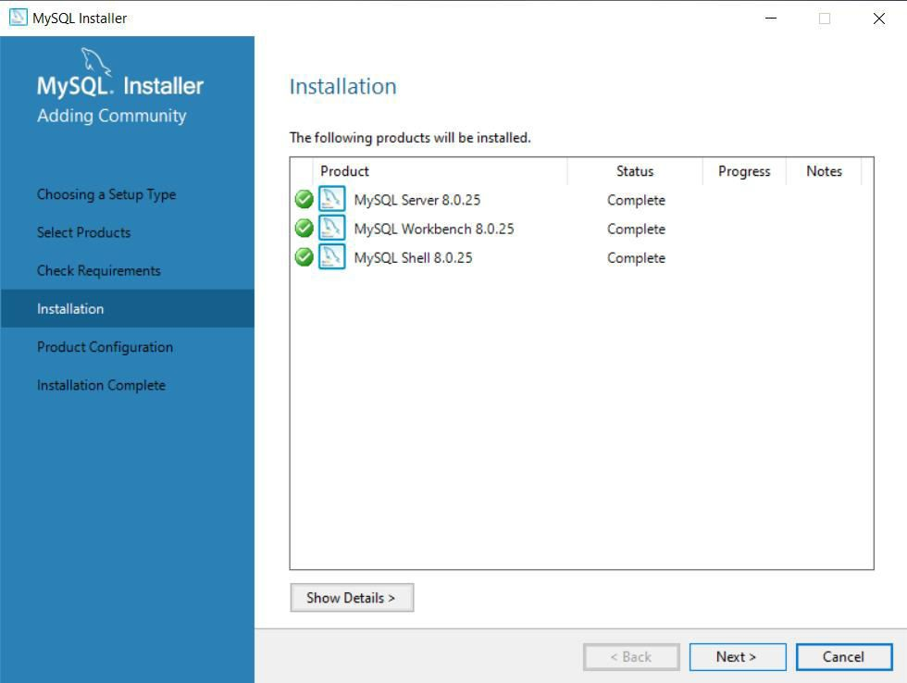2
✓ Step-6: In type and networking we choose configuration type, port as shown and click next

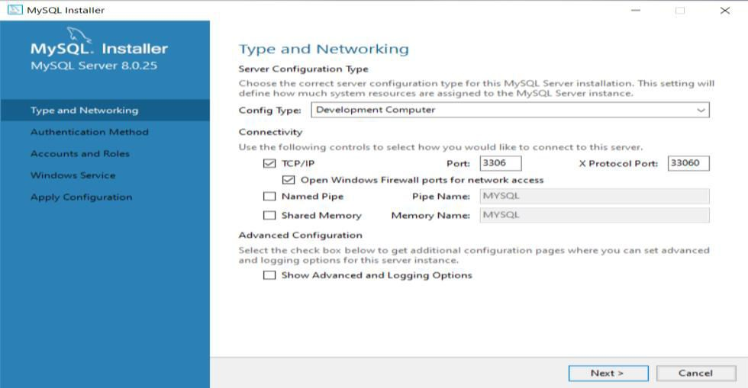1

2

✓ Step-7:In Authentication method choose, Use strong Password Encryption and click next

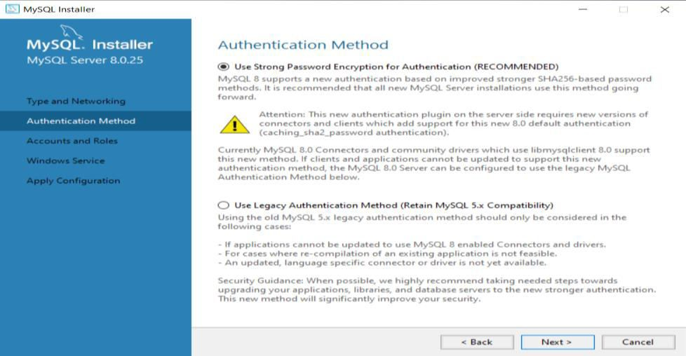1

2

✓ Step-8: In Accounts and roles set a password for root account and remember the password and click next

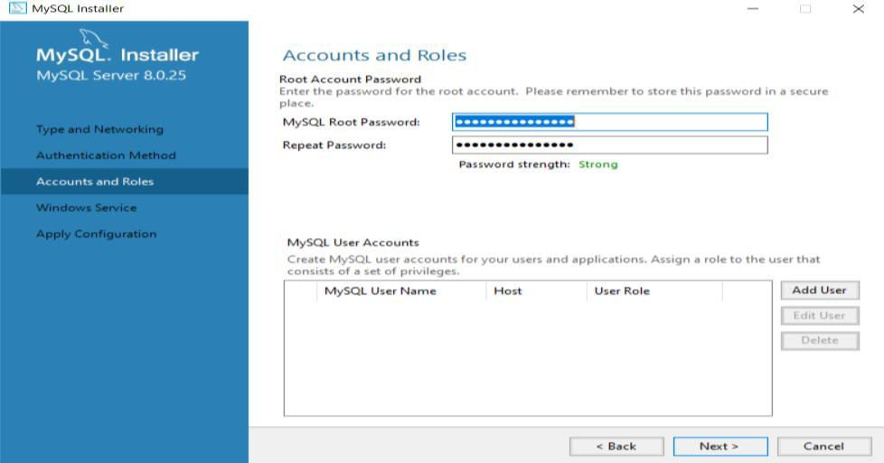1

2
✓ Step-9: Select Standard System Account in Window Services and click next

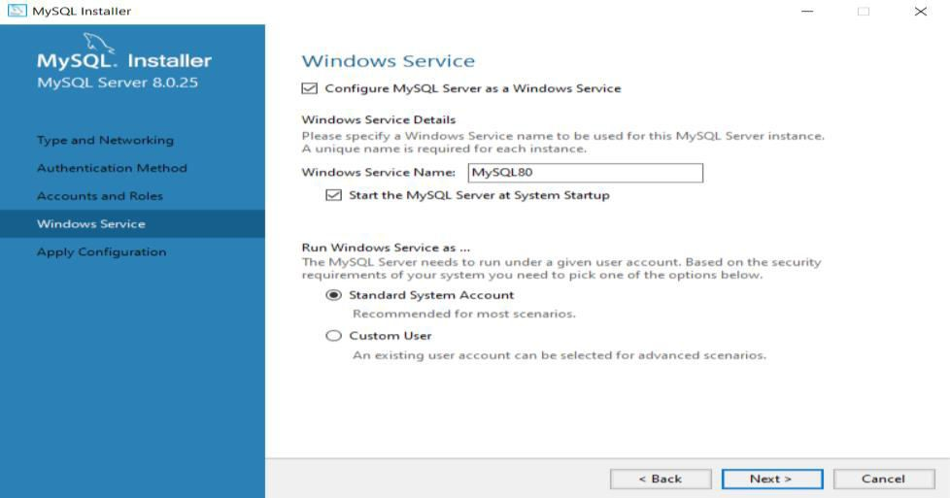1

2

✓ Step-10: After the configuration operations has completed click on finish and tick the
boxes to start workbench and shell and click on finish. Installation is completed

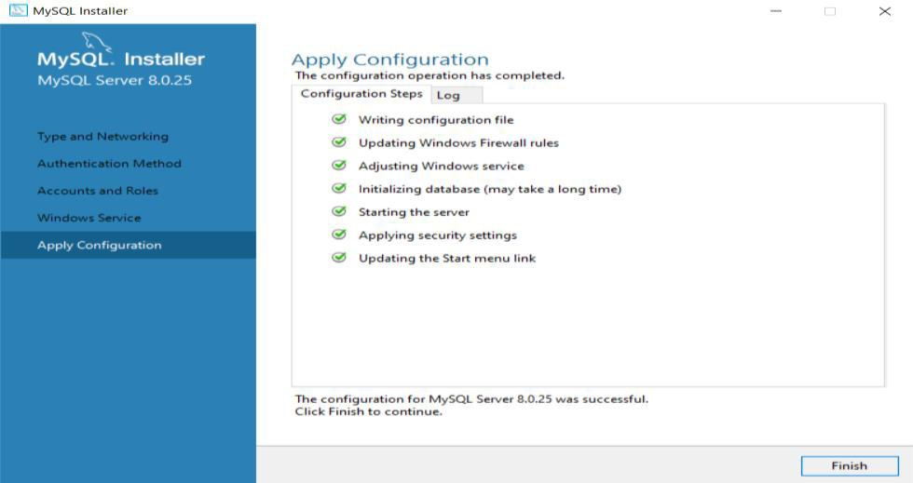1

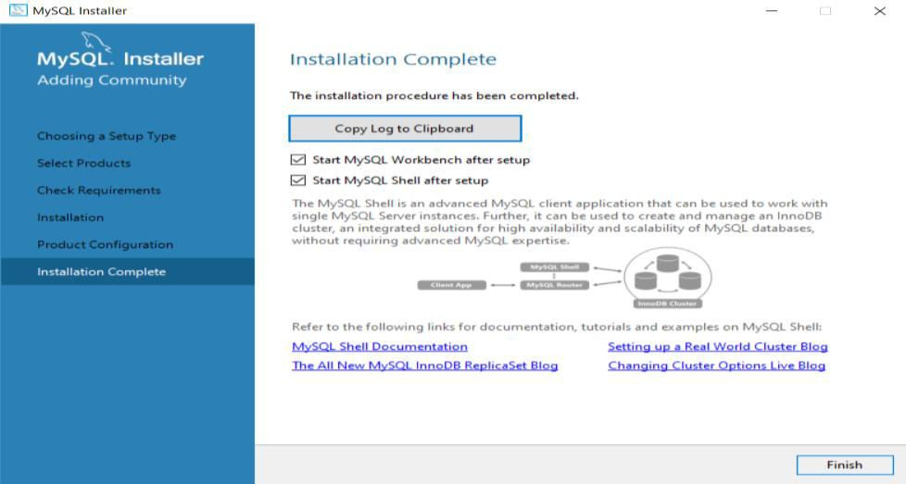2

3
▪ Verify MySQL Installation
✓ Step-1: Open the Command Prompt and navigate to the bin folder of MySQl
Server 8.0.25 i.e. c:\ program files\MySQL\MySQL Server 8.0\bin
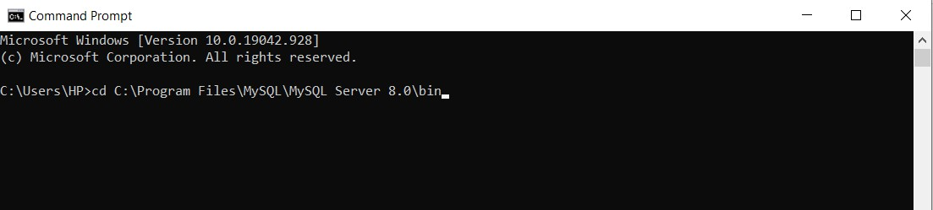

✓ Step-2: Run the command mysql –m root -p
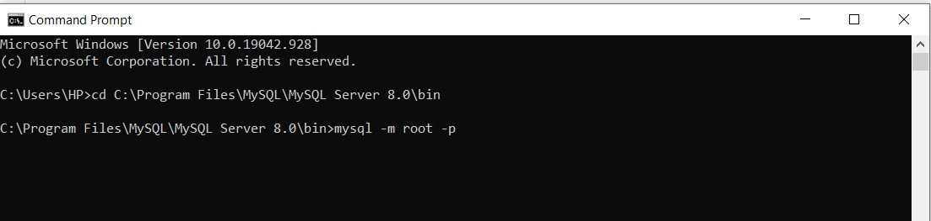

✓ Step-3: It will prompt you to enter the password and enter password created during the installation then it will show you the MySQl command line prompt as shown in the figure

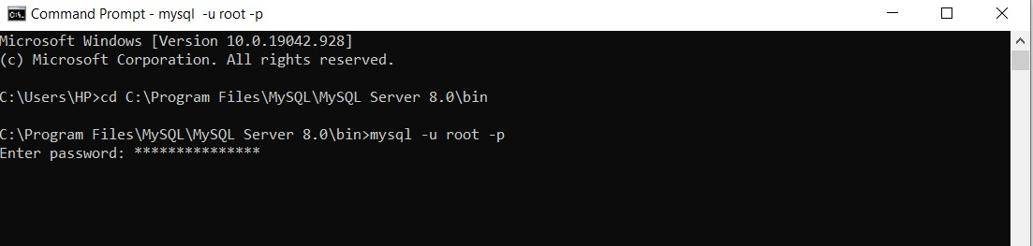

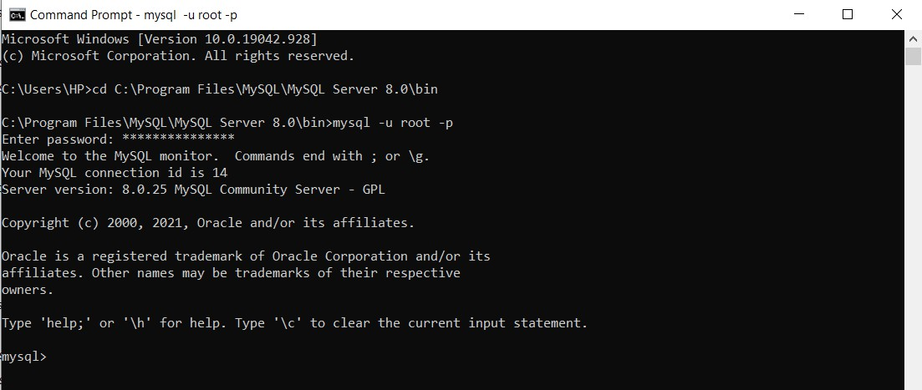
Working with MySQL Workbench

▪ MySQL New Connections
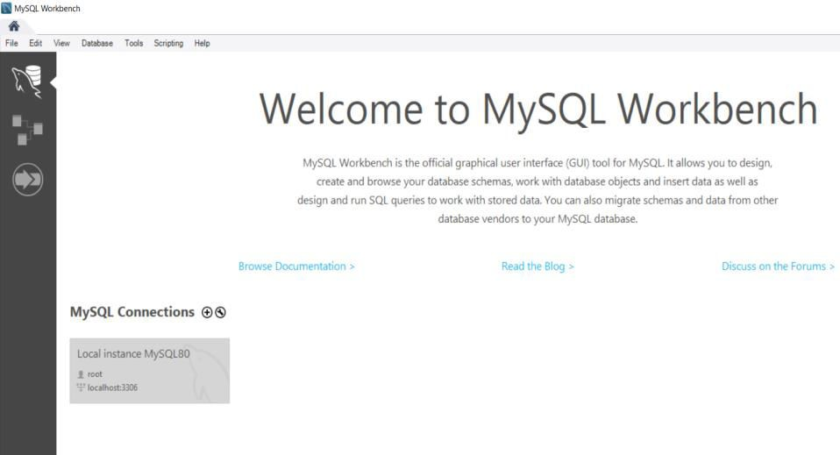✓ Step-1: Launch the MySQL Workbench and the following screen appear and you will find an Local instance which is already created during installation. To create a new connection click on the plus icon as shown in the figure

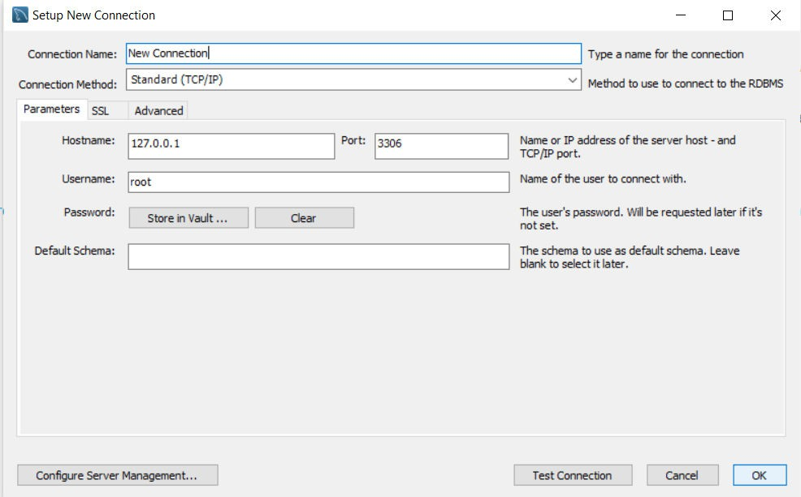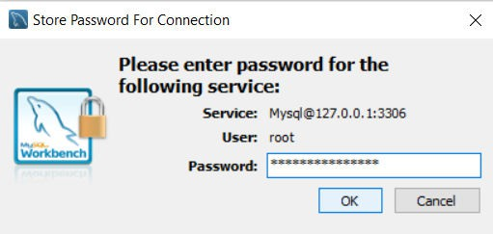✓ Step-2: Fill the box to create a connection, such as connection name. Then click the Store in Vault button to write the password for the given user account and click Ok
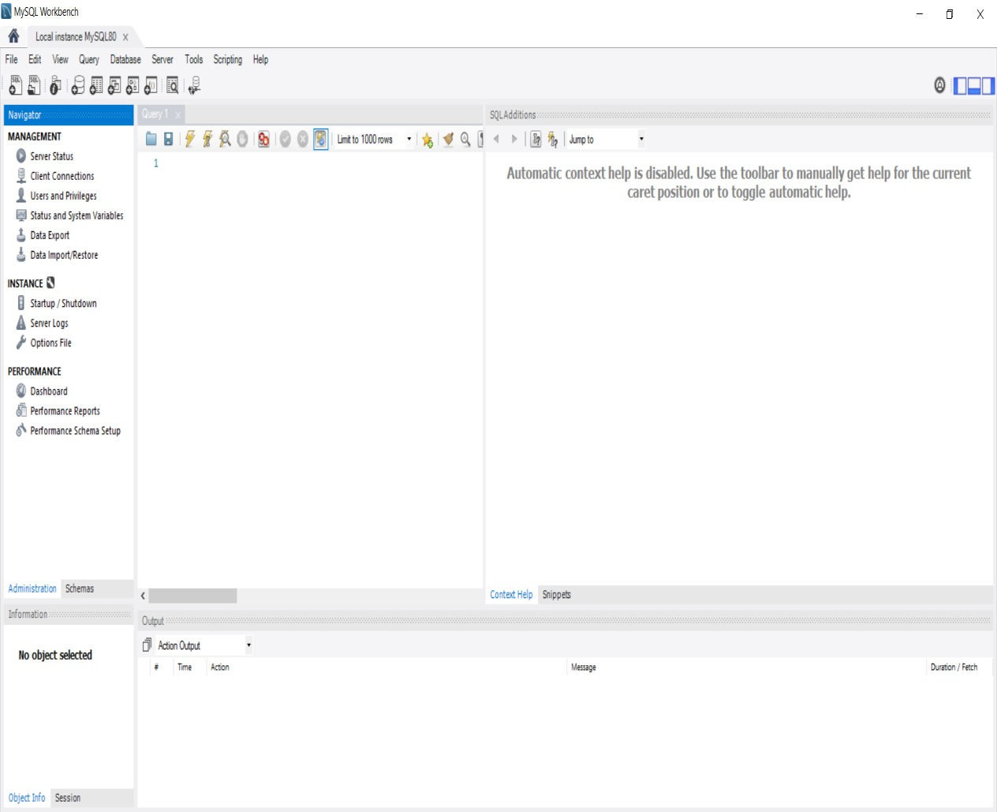✓ Step-3: Click on any of the connection created and give the related password to launch the MySQL Workbench screen

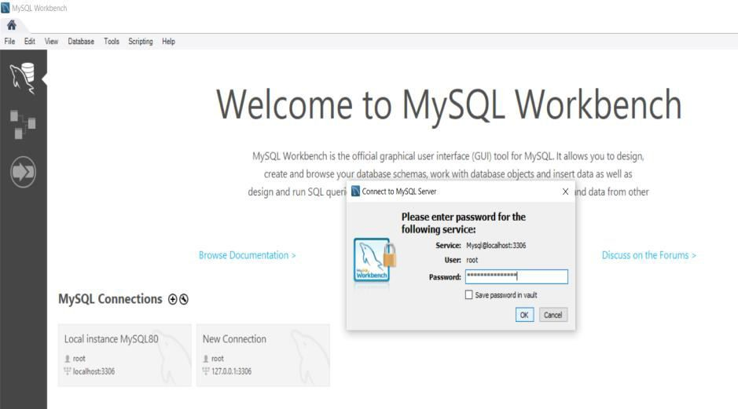

▪ Understanding Workbench

1
2
3

8 7

4

5 6

1. Connection tab-Information of current connection
2. Main menu bar- contains file,edit,view,query,server,tools and many more options
3. Main tool bar-contains icons to create schema,table,views,functions etc.
4. Administration tool-shows the information of the created tables, functions etc
5. Side bar panel-gives the information of selected object
6. Query result-it gives the output of the query written
7. Help panel
8. SQL Visual Editor- the panel where the query is written
SQL (Structured Query Language)

• Used to communicate with database.
• Used to perform task such as Updation, Retrieval, Insertion and deletion of data in the database.

SQL Commands

• SELECT - extracts data from a database
• UPDATE - updates data in a database
• DELETE - deletes data from a database
• INSERT INTO - inserts new data into a database
• CREATE DATABASE - creates a new database
• ALTER DATABASE - modifies a database
• CREATE TABLE - creates a new table
• ALTER TABLE - modifies a table
• DROP TABLE - deletes a table
• CREATE INDEX - creates an index (search key)
• DROP INDEX - deletes an index

Relational Database Management System (RDBMS)

• Basic for SQL.
• Stores data in the database in the collection of tables.
• RDBMS Systems: MySQL, Oracle

Tables

• Set of data that are organized in a model with rows and columns.
• Most common and simplest form of data storage in a relational database.

Fields

• Table with specific number of columns.
• For customer table it consist of fields ID, NAME, AGE, ADDRESS, and
SALARY. Schema
Schema diagram / ER diagram (Entity relationship) Schema is a blueprint.
SQL data types:

Int, float, varchar(), Date, char, Blob

Create database dbName;

dbName;

usedbName;

create table Employee()

dbName1

create table Employee1 ()

Drop DB

The DROP DATABASE statement is used to drop an existing SQL database. Syntax:
DROP DATABASE databasename;

Primary Key

• Specify a row uniquely.
• Contain UNIQUE values, and cannot contain NULL values. Foreign Key
• One table related to primary key of other table. Unique Key
• Provides uniqueness for column or set of columns. Join
• Table combines with any field.
1. Inner Join:Returns dataset that have matching values in both tables.

2. Left Outer Join: Returns all records from the left table and matched records from the right table.

3. Right Outer Join: Returns all records from the right table and matched records from the left table.

4. Outer (Full) Join: Combined result of both left and right tables.

SQL View
5. Cross Join: It is same as the Cartesian product.

Number of rows in the first table* Number of tables in the second row.

View is a virtual table based on the result-set of an SQL statement.

Contains rows and columns.

Create view vName as Select * from Employee where age < 50; Select * from vName;

SQL Index

Indexes are used to retrieve data from the database more quickly than otherwise.

The users cannot see the indexes, they are just used to speed up searches/queries.

Create Index Syntax

CREATE INDEX index_name ON table_name;
Subquery
A Subquery is used to return data that will be used in the main query as a
condition to further restrict the data to be retrieved.
Correlated Subqueries: They are used to select data from a table referenced in the outer query. The subquery is known as a correlated because the subquery is related to the outer query. In this type of queries, a table alias also called a correlation name must be used.
Inline View: It is not a real view but a subquery in the FROM clause of a SELECT
statement.

Order by
Used to sort the data in ascending or descending order, based on one or more
columns. Some databases sort the query results in an ascending order by
default.

Group by
Used in collaboration with the SELECT statement to arrange identical data into
groups.

Stored Procedures

These are nothing but functions/Methods which will hold verified SQL
statements…

Inline View

It is not a real view but a subquery in the FROM clause of a SELECT statement. Syntax:
SELECT column_list✓FROM (SELECT column_list FROM table_name WHERE
condition) AS new_name;

PROGRAMES & OUTPUT

• Creating table, adding values to table use employeedatabase1;
show tables;
select*from employeee;

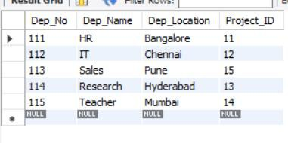

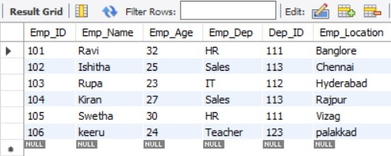

• Adding column to table

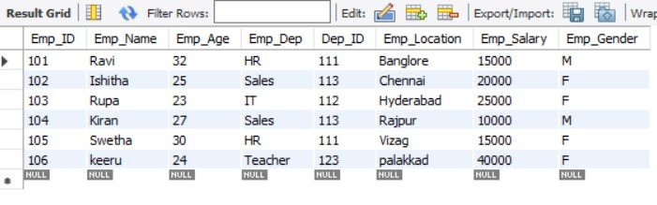

• Filter Results with Where Statement

select Emp_Name,Emp_Age from employeedatabase1.employeee where
Emp_Location='chennai';

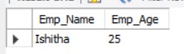
• Delete values in Table
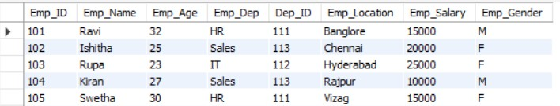

• Order by
select avg(Emp_Salary) AS Avg_Salary,Emp_Location from employeedatabase1.employeee group by Emp_Location having Avg_Salary>12000 order by avg(Emp_Salary) desc;
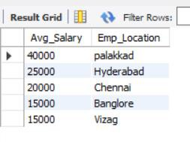
• Inner join Select employeee.Emp_Name,employeee.Dep_ID,department.Dep_Location, department.Dep_Name
from employeedatabase1.employeee
inner join employeedatabase1.department on employeee.Dep_ID=department.Dep_No;

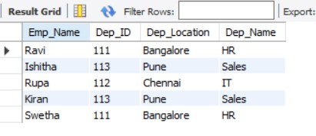
• Outer join-Left join
select employeee.Dep_ID,employeee.Emp_Location,department.Dep_Name,d epartment.Dep_Location
from employeedatabase1.employeee
left join employeedatabase1.department
on employeee.Dep_ID=department.Dep_No;

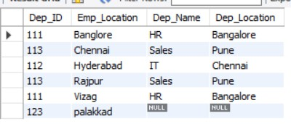
• Outer join-Right join select employeee.Emp_Name,employeee.Dep_ID,department.Dep_Location,d epartment.Dep_Name
from employeedatabase1.employeee
right join employeedatabase1.department on employeee.Dep_ID=department.Dep_No;

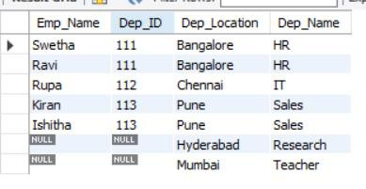
• Cartesian join/ Cross join

SELECT* FROM employeedatabase1.department CROSS JOIN
employeedatabase1.employeee where Emp_Salary>12000;

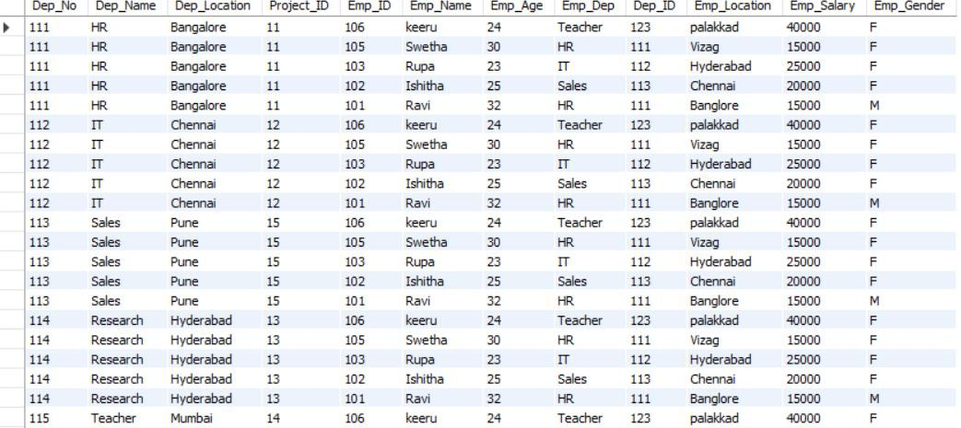

• Sub-Query using Correlated query and Inline view

SELECT* FROM employeedatabase1.employeee e1 where 2=(select count(Emp_ID) from employeedatabase1.employeee e2 where e2.Emp_Salary>e1.Emp_Salary);------> Correlation

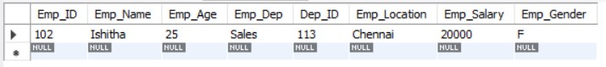

• SELECT*FROM (SELECT SUM(Emp_Salary) AS "Total Salary",Emp_Gender AS "Gender" From employeedatabase1.employeee GROUP BY Emp_Gender) AS GENDER;…………>Inline view
